**Full Name: ____________________________**

**Class Exercise Challenge #6**

**GAME 2343/2347 and IMED 1345/2345**

After today’s lecture and hands on activities, you will need to complete the following challenge:

1. Create C# script for guess the number game, have the player guess from 1 to 10, if the guess number is higher than the actual number, the Console should read “Too high”, if the number is low, the Console should read “Too low”. If they get it right, the Console should read, “You Win!”. The player should guess with a public int field, but submitting the guess number by Disabling the cube.

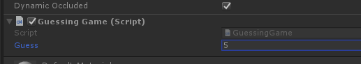

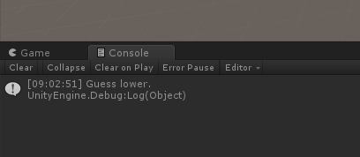

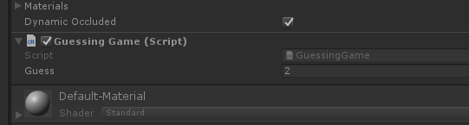

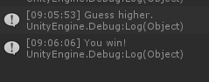

Use this C# code to generate the random number:

int randomNumber;

void Start()

{

randomNumber = Random.Range(1, 10);

}

2. Toggle between the two states (checked and unchecked), you will need to take the screen shot, copy and paste it below.

3. Upload this document to eCampus before the due date.